**IMPLEMENTING BLOCKCHAIN BASED INFORMATION FLOW**

**A CASE STUDY OF KOM CONSULT**

**KEVIN MUTUGI KITHINJI**

**SCT221-0415/2020**

**A proposal submitted to the Department of Information Technology in partial fulfillment of the requirement for the award of the Degree of Bachelor of Science Information Technology at Jomo Kenyatta University of Agriculture and Technology.**

**OCTOBER 2023**

# DECLARATION

I Kevin Mutugi Kithinji declare that this is my project proposal and has never been submitted to this or any other University for the award of Degree or any other award.

Student: Kevin Mutugi Kithinji

Sign………………………. Date………………………….

Supervisor: Francis Thiong’o

Sign……………………… Date………………………….

# ABSTRACT

The management of construction projects requires adequate techniques to support the continual exchange of information across the stakeholders. Onsite assembly is a critical stage for modular construction. Its success or failure depends on accurate information sharing among numerous stakeholders who unfortunately, often possess unsynchronized information. The aim of this project is to integrate blockchain and smart contracts into information flows used across the life cycle stage of a construction project.

The proposed solution involves developing smart contracts, developing a Decentralized Application (DApp) to access data in the blockchain using smart contacts. DApps are able to interact using smart contracts with blockchain and allow users to perform operations through a web user interfaces.

The research objective will be to develop a system that will facilitate the efficient and timely relay of information needed in critical decision making in buildings construction.

The specific objectives include conducting survey using interviews, designing a system prototype and validating and testing the developed prototype.

The project methodology involves developing prototypes that can be tested and user feedback received and if any changes are need then they are implemented.

The scope of the project is limited to developing a prototype of a web based interface that the users can interact with and developing smart contracts to run on the blockchain and evaluating its effectiveness.

The project's budget includes costs associated with requirements gathering, computational resources and project management.

The project requirements include access to building construction experts, expertise in blockchain technology and developing smart contracts, and access to computational resources.

The project schedule involves problem identification, requirements gathering, data collection, data analysis, design, prototype development, prototype testing, refinement, final implementation and documentation.

Output of this research is to determine the effectiveness of the new prototype in reducing the repetitive paper work, raising the trustworthiness of the approvals, and timely relay of instructions and approvals and disapprovals of requested changes.

## Table of Content

DECLARATION i

ABSTRACT 1

Table of Content 2

Acronyms 3

Definition of terms 3

List of Figures 3

CHAPTER 1 4

INTRODUCTION 4

1.1 Research Background 4

1.2 Problem Statement 6

1.3 Proposed Solution 7

1.4 Objectives 7

1.4.1 Main objective 7

1.4.2 Specific objectives 7

1.5 Research Questions 7

1.6 Justification 8

1.7 Scope 8

CHAPTER 2 9

LITERATURE REVIEW 9

2.1 Introduction 9

2.2 Performance Evaluation 10

2.3 Research Scope and Limitation 10

2.4 Significance of Study 10

2.5 Expected Research Output 11

2.6 Research Methodology 11

2.7 Conceptual Framework 13

2.8 Proposed Schedule 14

2.9 Gantt chart 14

2.10 Budget 14

2.11 Project requirements 15

2.11.0 Hardware requirements 15

2.11.1 Software Requirements 15

2.12 References 15

# Acronyms

DApp - Decentralized Application is an application built on a decentralized network that combines a smart contract and a frontend user interface.

DLT – Distributed Ledger Technology is a type of data structure that exits across multiple computing devices, called nodes, which are generally spread over locations or regions throughout the internet.

TCP/IP - Transmission Control Protocol/Internet Protocol is a suite of communication protocols used to interconnect network devices on the internet.

POW - Proof of Work is a decentralized consensus mechanism used in blockchain technology that [requires network members to expend significant computational effort to solve an encrypted hexadecimal number](https://www.investopedia.com/terms/p/proof-work.asp). [This process is also called mining, and miners are rewarded for their work](https://www.investopedia.com/terms/p/proof-work.asp). [Prof of work allows for secure peer-to-peer transaction processing without needing a trusted third party](https://www.investopedia.com/terms/p/proof-work.asp)

POS - Proof of Stake is a consensus mechanism used in blockchain technology to validate transactions and create new blocks in a blockchain. Under PoS, validators are chosen based on the number of staked coins they have. Validators hold and stake tokens for the privilege of earning transaction fees.

P2P - Peer to Peer is [a computing or networking decentralized platform whereby two or more network members interact directly with each other, without intermediation by a third party](https://www.investopedia.com/terms/p/peertopeer-p2p-service.asp).

# Definition of terms

Smart Contract - It is a program that is stored on a blockchain that runs when predetermined conditions are met.

Blockchain - It is a distributed database that is maintained across computers linked in a network that maintains a continuously growing list of ordered records called blocks that are linked using cryptographic hashes. Each block contains a cryptographic hash of the previous block, a timestamp and transaction data.

# List of Figures

Figure 1 Prototyping Methodology 12

Figure 2 Conceptual Framework 13

Figure 3 Project Schedule 14

Figure 4 Gantt Chart 14

Figure 5 Budget 14

# CHAPTER 1

# INTRODUCTION

## Research Background

In the buildings construction industry when a construction project is being carried out there is a book called instructions book. This book keeps a record of instructions written down by the construction’s stakeholders mainly being the structural engineer(in charge of ensuring the structure of the building is intact), architect, quantity surveyor(in charge of making the cost estimates of the construction of the building), project manager(in charge of ensuring all other stakeholders work as a team), mechanical engineer(in charge of water pipes, drainage, firefighting utilities) and electrical engineer(in charge of electricity cabling of the building). When a stakeholder goes to the site and there are instructions given to the workers on the ground, these instructions must be written in the instructions book. Currently the engineer must have his/her own copy, the architect must also have his/her own copy, and one copy must remain at the site. This instructions book is important in that if it’s the engineer who was at the site, the architect can come and read what the engineer has instructed, if it’s the architect who was at the site the engineer can come and read what the architect has instructed, or if it is both the engineer and architect who were at the site, the owner/client can come and read what they have instructed. Also the county inspectors use this instructions book when they occasionally come to inspect if the building construction is being done according to set standards. Current method used to document these instructions is through a manual book. Sometimes someone can remember of an instruction they forgot to write in the book and they are far away from the site and decide to write these instructions in a WhatsApp group that they may have formed for the project. The proper recording and storage of these instructions whether in the manual book or WhatsApp messages is vital because they are admissible in court should anything happen and there need to be proof of them being recorded. The issue with this mode of record keeping is it prone to loss or damage and also duplication of records. As much as WhatsApp is a modern technology some people may not see the messages, for instance if they have so many groups and contacts, some people overlook checking messages in some groups or they tend to just focus on the top messages only. Others will just take a peek at the message and assume that if it is from a certain stakeholder, then it does not concern them and they wouldn’t read the whole message.

When the client requests any type of changes in the building, these changes must be assessed and approved by all the stakeholders especially the architect and the engineer. The instructions and the approval from each stakeholder must be documented in the instructions books. There are cases where some stakeholders may give their approval through WhatsApp and as stated earlier this can be challenging as an effective mode of communication.

KOM Consult is a consultancy firm that deal with supervision and construction of buildings that range from homes, mansions, apartments to high-rise buildings. They provide the engineering expertise in buildings constructions. While there are systems to support document management, communication between them is limited and mainly involves activities susceptible to human error.

Owing to its decentralized consensus mechanism, blockchain has the potential to improve information sharing effectiveness on construction management. Blockchain can store data securely and easily for query on the chain, providing support for the long construction cycle and reducing unnecessary work. The focus of the proposal is on reducing human error and increasing the reliability and transparency of decision making process on construction sites. Blockchain is an important research area that can be used to improve information sharing effectiveness on construction management.

Blockchain technology belongs to the wider digital ledger family, of which there are three fundamental types: centralized, decentralized and distributed. The research area will be on distributed ledger technology. The Distributed Ledger Technology (DLT) is a type of data structure that exits across multiple computing devices, called nodes, which are generally spread over locations or regions throughout the internet (IP/TCP), which acts as the base technology for information sharing. The ledger contains records i.e. transactions, collected into blocks, which are linked using cryptography (V. Ciotta et al., 2021).

A blockchain has four interdependent core layers:

1. Ledger which is a record of transactions grouped into blocks.
2. Peer to Peer network.
3. Protocol comprising governance (consensus rules).
4. Application layer which contains relations (e.g. smart contracts) that are allow information to flow through the system.

Permission less blockchain use proof based consensus algorithms, including Proof of Work (POW) and Proof of Stake (POS), which are the most common. These blockchains are also public (e.g. Bitcoin and Ethereum) since anyone can join the network (V. Ciotta et al., 2021).

The main properties of blockchain include:

Distribution – information is recorded by distributing it among several nodes to ensure IT security and system resilience.

Traceability – each transaction on the register is traceable in every respect and can be mapped back to its precise origin.

Disintermediation – blockchain platforms allow the management of transactions without intermediaries: in other words without the presence of trusted central bodies.

Transparency – the content of the register is transparent and visible to everyone in the public blockchain as well as easily accessible and verifiable.

Immutability –once written into the register, the data cannot be changed without the network consent.

Trust – this is built by the P2P network via the consensus mechanism, with no need for intermediaries, even though there is no trust among the parties involved.

Opportunity to program transactions – it is possible to schedule actions that take place when certain conditions occur on the blockchain using smart contracts (V. Ciotta et al., 2021).

In the context of construction information flow, blockchain play a crucial role in enabling to bypass the need for emails and other more traditional transmission channels during construction project. This is achieved by certifying all the information containers exchanged and their corresponding information flows on the blockchain. This produces a universal and reliable source of information for the stakeholders both during and following the construction process.

## Problem Statement

There is a lack of proper communication between the client, contractor, architect and engineer, especially when a client wishes to make changes to certain elements of the structure under construction and it is implemented without the consultation of either the architect or the engineer or in some cases both. This can lead to comprises in the integrity of the structure. There is a need to come up with a system that bypasses obsolete and incomplete data exchange processes, while concurrently providing a blockchain tool to create an immutable, trustworthy source that assembles the entire storyline of the structural safety information exchanges that take place during the building process.

## Proposed Solution

The proposed solution is to develop a web user interface that will be deployed as a decentralized application that communicates using smart contracts running in the blockchain. The system will involve a message notification system that will alert all stakeholders of the any new requests, recommendations, approvals and current progress in the field and on site. There will be an interface to key in the instructions and making approvals and another interface for viewing the instructions and approvals or disapprovals.

## Objectives

### Main objective

The main objective of this research is to develop a system that will facilitate the efficient and timely relay of information needed in critical decision making in buildings construction.

### Specific objectives

The specific objectives of this research are as follows:

1. I am going to conduct a survey using interviews.
2. I am going to design a system prototype.
3. To develop smart contracts for handling information flow.
4. To develop a web user interface that will allow for entering details and viewing information/notifications.
5. To validate and test the developed prototype.

## Research Questions

The research questions for this project proposal are:

1. How can blockchain technology be used to enhance the efficiency of information flow in buildings construction?
2. What are the existing methods?
3. How will I conduct my interview?
4. What is the best blockchain platform to use for information flow?
5. How can the developed information flow application be evaluated for effectiveness?
6. What Testing techniques can be used to test the prototype?
7. What are the methods that will be implemented to ensure user friendliness in the system?

## Justification

The development of an information flow application using blockchain technology will facilitate effective information flow in buildings construction industry. The proposed solution will also contribute to the advancement of blockchain technology research, particularly in the area of construction industry.

## Scope

The scope of this project is limited to the development of a web user interface that will communicate with smart contracts that will run in blockchain. The application will be tested and evaluated for effectiveness.

# CHAPTER 2

# LITERATURE REVIEW

## Introduction

Blockchain is a distributed database which is shared among and agreed upon a peer to peer network. It consists of a linked sequence of blocks, holding time stamped transactions that are secured by public key cryptography and verified by the network community. Once an element is appended to the blockchain, it cannot be altered, turning a blockchain into an immutable record of past activity (Partala, J., 2018).

Once the block is full, nodes simultaneously perform Proof of Work (mathematical operations that are difficult to solve but whose correct solution is easy to verify. These mathematical operations are indispensable to the operation of the system, as they force the verifying nodes to expend processing power which would be wasted if they included any fraudulent or invalid transactions. The first node that succeeds in solving a proof of work problem broadcasts the solution, along with the block of transactions and when 51% of the processing power of the network votes to approve a block, nodes begin recording new transactions to a new block, amending them to all previous blocks(CoinMarketCap, 2018,).

The blockchain technology solves double-spend problem with the help of public-key cryptography, whereby each user is assigned a private key, and a public key is shared with all other users. The main idea of the blockchain is a distributed database comprising records of transactions that are shared among participating parties. Every transaction is verified by the consensus of most of the participants in the system, making fraudulent transactions unable to pass collective verification. Once a record is created and accepted by the blockchain, it can never be altered (Zhao et al., 2016).

This allows for the creation of a jointly generated electronic time stamp that all participants can trust, even if they do not trust one another. In this manner it is easy to verify the origin and accuracy of the information whatever its source. No external intermediary (such as a centralized server) trusted by all the parties is required to validate the data (Seebacher et al., 2017).

## Performance Evaluation

|  |  |
| --- | --- |
| **Factor** | **Variable** |
| Functionality | Security levels  No of users  Permission management  Error reporting  scalability |
| User friendliness | Ease of use of graphical interface  Ease of learning  User manuals |
| Time | Duration  Availability of necessary modules  Completeness  Interoperability |

## Research Scope and Limitation

Considering the construction industry, blockchain technology has been employed in different fields, such as supply chain management, risk management, smart contracts, logistics, carbon estimation, building information modeling (BIM), the IoT and sustainability. Blockchain’s potential in the construction industry should be thoroughly analyzed to glean insights from various stakeholders’ points of view. The use of Blockchain to enhance construction procedure management and service delivery necessitates identifying new trends, providing research findings, and suggesting prospective future research pathways.

## Significance of Study

Blockchain technology provide a traceable and transparent track for products and materials, but it can also give vital information that may be utilized in decision-making as a foundation plan for the decommissioning of a structure and the reuse of the materials in every construction project through the appropriate understanding of their properties and composition. Smarter and more sustainable methods may be implemented due to technological innovation and improvements in the building sector. Blockchain technology has the potential to improve several areas, including information flows, and the simplicity with which approvals are tracked in real time.

## Expected Research Output

Output of this research is to develop a web based application that will interact with smart contracts running in blockchain.

## Research Methodology

I will use Object Oriented Methodology. Prototyping is a software development methodology that involves building a preliminary version of a software system or application in order to test its design and functionality. The prototype is created in an iterative and incremental manner, with feedback from stakeholders incorporated at each stage to refine and improve the design.

The prototyping methodology involves the following steps:

1. Requirement gathering: The first step in prototyping is to gather and document the requirements of the system or application. This involves identifying the user needs, business requirements, and technical specifications that the software must meet. I will gather my requirements by conducting interviews and using questionnaires.
2. Design: Once I have gathered the requirements, I will make a design of the prototype. This will involve creating a preliminary model or sketch of the prototype that will be used to guide the development process.
3. Prototype development: In this step, I will develop a preliminary version of the prototype. This prototype is typically not fully functional but is designed to demonstrate the key features and functionality of the software.
4. Prototype testing: I will test the prototype to identify any design flaws, bugs or usability issues. Feedback from stakeholders will be gathered, and any necessary changes are incorporated into the design.
5. Refinement: Based on feedback and testing, the prototype will be refined and updated to incorporate changes and improvements. This process will be repeated until the prototype meets the requirements and expectations of stakeholders.
6. Final implementation: Once the prototype is refined and fully functional, the final version of the prototype will be developed and implemented.

Prototyping methodology is particularly useful in software development projects where the requirements are not fully understood, or where the user needs are complex or difficult to define. By creating a preliminary version of the software, the prototyping methodology allows for rapid feedback and iteration, resulting in a final product that meets the requirements and expectations of stakeholders.

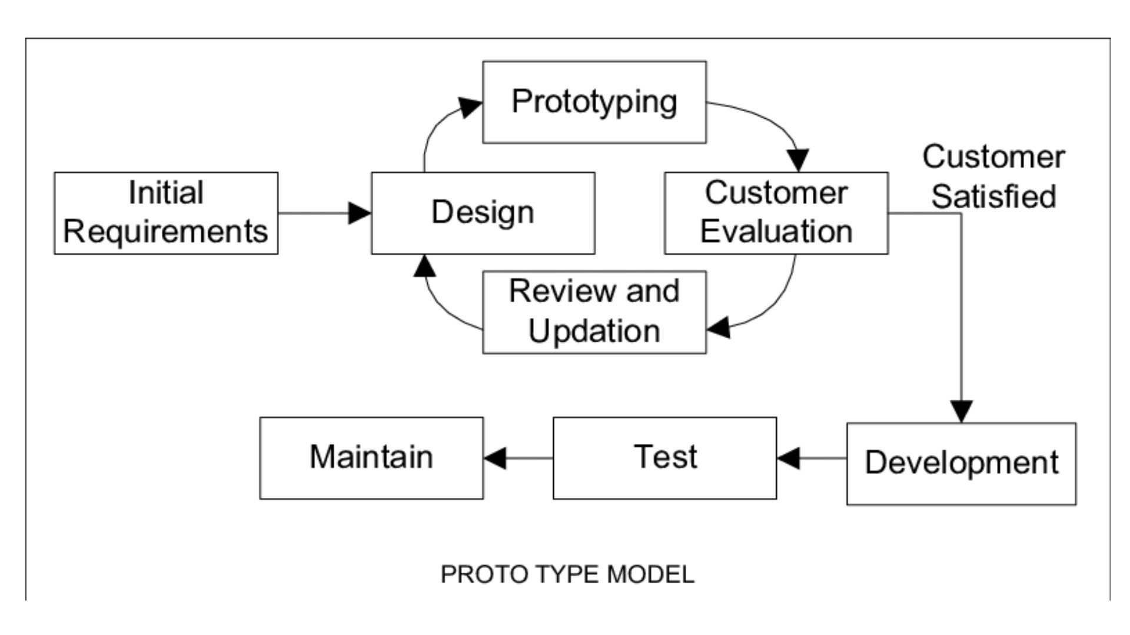

Figure 1 Prototyping Methodology

## **Conceptual Framework**

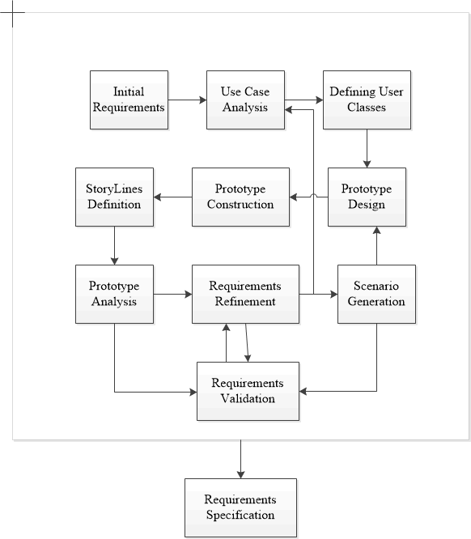

Figure 2 Conceptual Framework

## Proposed Schedule

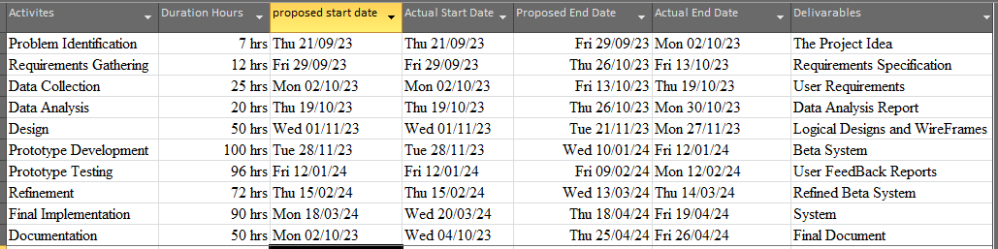

Figure 3 Project Schedule

## Gantt chart

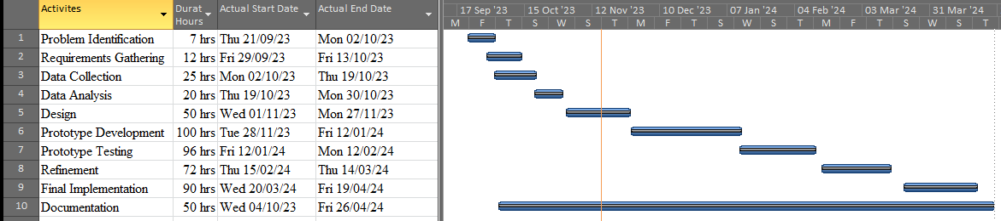Figure 4 Gantt Chart

## Budget

The budget for this project will include travel costs, research costs on smart contract development and web application development and printing. The total budget for this project is estimated to be Ksh 7,500.

|  |  |  |  |
| --- | --- | --- | --- |
| Number | Item Description | Quantity | Amount (Ksh) |
| 1 | Laptop | 1 | 50,000(provided) |
| 2 | External Hard disk | 1 | 8000(provided) |
| 3 | Operating system | 64 bits | provided |
| 4 | Bundles | 10GB | 3500 |
| 5 | Transport |  | 2000 |
| 6 | Printing |  | 2000 |
|  | **Total** |  | 7,500 |

Figure 5 Budget

## Project requirements

### Hardware requirements

The hardware requirements for this project will include:

1. A computer with a minimum of 8GB RAM and 500 GB storage.
2. Flash disk with minimum 64 GB storage.

### Software Requirements

The software requirements for this project will include:

1. Javascript programming language.
2. Solidity programming language.
3. Vs Code for smart contract development.
4. Node js for web application development.
5. Git for version control.
6. Microsoft Office for documentation (MS word), analysis (MS Excel), Presentation (MS Power Point)

## References

CoinMarketCap. (n.d.). Retrieved May 10, 2018, from https://coinmarketcap.com/

Crosby, M., Pattanayak, P., Verma, S., & Kalyanaraman, V. (2006, 2). Blockchain Technology: Beyond Bitcoin. *Appl. Innov.*, 71.

Czepluch, J., Lollike, N., & Malone, S. (n.d.). The Use of Block Chain Technology in Different Application Domains Bachelor Project in Software Development. Retrieved March 13, 2018

Dobrovnik, M., Herold, D., Fürst, E., & Kummer, S. (2018, 2 18). Blockchain for and in Logistics: What to Adopt and Where to Start. *Logistics*.

Fernando, Y., & Saravannan, R. (2021, 4). Blockchain technology: Energy efficiency and ethical compliance. *J. Gov. Integr.*, 88–95.

Gatteschi, V., Lamberti, F., DeMartini, C., Pranteda, C., & Santamaria, V. (2018, 10 20). Blockchain and Smart Contracts for Insurance: Is the Technology Mature Enough? *Future Internet*.

Hassani, H., Huang, X., & Silva, E. (2018, 2 34). Big-Crypto: Big Data, Blockchain and Cryptocurrency. *BDCC*.

Partala, J. (2018, 2 ,18). Provably Secure Covert Commmunication on Blockchain. In *Cryptography.*

Seebacher, S., & Schüritz, R. (2017). Blockchain Technology as an Enabler of Service Systems: A Structured Literature Review. *Springer Nature*, 279, 12–23.

V. Ciotta, G. M. (2021). Integration of blockchains and smart contracts into construction information flows: Proof-of-concept,. *Automation in Construction,, Volume 132,*. Retrieved from https://www.sciencedirect.com/science/article/pii/S0926580521003769

Zhao, J., Fan, S., & Yan, J. (2016, 2 12). Overview of business innovations and research opportunities in blockchain and. *Finan. Innov.*

Zheng, Z., Xie, S., Dai, H.-N., Chen, X., & Wang, H. (n.d.). Blockchain challenges and opportunities: A survey. *Int. J. Web Grid Serv.*, 352–375. Retrieved 2018